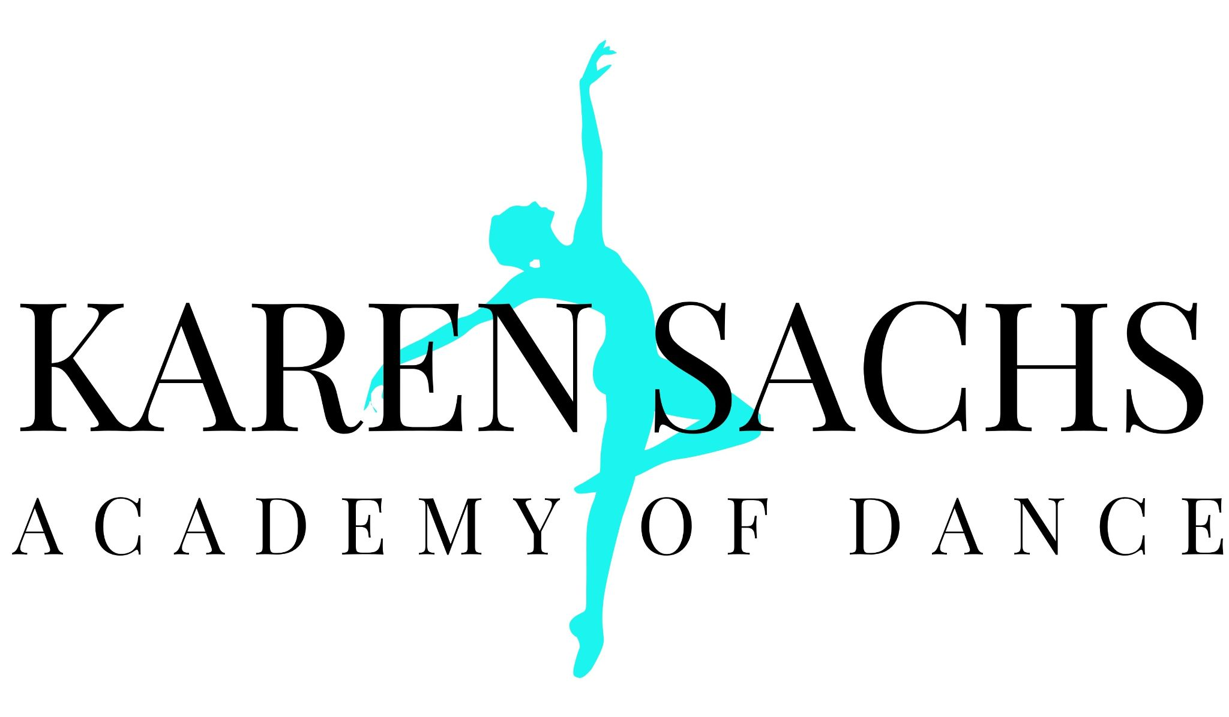
Summer Camp Registration 2022

Type of Credit Card: ______________
CC# __________________________________ Exp: _________ Security: ________
Signature: _____________________________ Amount Paid: _________

Parent Name: ________________________________ Cell Phone: _________________
Email Address: __________________________________________________________
Street Address: __________________________________________________________
City: ______________________________ Zip Code: ____________________________

Students Name Birthday Class Day Time Price

_________________ ________ ________________________ ______ ________

_________________ ________ ________________________ ______ ________

_________________ ________ ________________________ ______ ________

_________________ ________ ________________________ ______ ________

_________________ ________ ________________________ ______ ________

To my knowledge there are no physical disorders that would prevent my child/children from performing strenuous activity. I waive responsibility of B’More Dance Academy, formerly Karen Sachs Academy of Dance for any injury or illness which might result from participation in dance class, including COVID. By signing below, I also give my permission to the academy to use my child’s picture on their website or for social media purposes and to charge tuition.

Are there any allergies/conditions our staff should be aware of? ___________________________________

Parent’s Signature: _____________________________________________________ Date: ______________

Bookkeeping Purposes: AMOUNT PAID ________________ FOR ______________ Date: __________

